Introduction

Build Your Advanced Agent With n8n

AI-Driven Multi-Agent Healthcare System

Introduction & Motivation
The integration of Generative AI (GenAI) and Large Language Models (LLMs) has significantly transformed the healthcare sector by enabling advanced natural language processing, improving access to medical information, and streamlining patient interactions. AI-powered solutions can assist in diagnosing conditions, providing health recommendations, and offering 24/7 support to patients.
Despite the abundance of medical knowledge, accessing personalised and reliable health information remains a challenge. Many existing healthcare systems provide generic responses and lack contextual awareness. HealthSense AI is designed to bridge this gap by leveraging LLMs and no-code multi-agent orchestration in n8n to offer intelligent, context-aware health information assistance.

Core Objectives
- Understand Agentic AI concepts and how multi-agent systems orchestrate healthcare workflows.
- Build specialized healthcare AI agents using n8n with no-code tools.
- Integrate structured healthcare datasets (doctors, hospitals, diagnostics) into intelligent agents.
- Automate doctor booking, hospital comparison, emergency routing, and diagnostics information retrieval.
- Implement Natural Language Processing (NLP) - Accurately interpret and process medical terminology.
- Provide Real-Time Doctor and Hospital Recommendations - Offer users relevant medical support.
- Ensure Compliance and Ethical AI Usage - Maintain HIPAA and GDPR compliance.

Scenario
Patients interact with a HealthSense AI system through chat to:
- Find available doctors and book appointments.
- Compare hospitals based on specialization, services, and emergency availability.
- Retrieve recommended diagnostic tests and preparation guidelines.
- Automatically route their queries to the appropriate intelligent agent.
All tasks are to be handled by a modular AI agent system in n8n, without writing code.

PRE-REQUISITES: GET READY FOR THE SESSION
Before the session, complete the following:
Accounts Required:
- n8n Cloud or Self-hosted instance
- OpenAI or any LLM API key (with GPT-4 access)
- Google Sheets account (for hospital/lab data storage)
- Optional:Twilio or similar SMS service for messaging (API key & verified number)
Basic Tools Setup:
- Ensure all APIs are working and whitelisted
- Ensure JSON agent definitions are uploaded into n8n
- Confirm you can test webhooks locally or via a live URL
Local Files/Folders:
- n8n Json files - Click here to Download
Keep the following files ready (shared with you):
  - Coordinator_Agent.json
  - Doctor_Booking_Agent.json
  - Hospital_Comparison_Agent.json
  - Diagnostics_Agent.json

Dataset Overview
To build an effective and reliable AI-driven healthcare assistant, HealthSense AI will use structured datasets stored in MySQL.***
- Linked here - HealthSense AI _ Data
Hospital General Information Dataset
- Contains hospital names, locations, specialties, capacity, and contact details.
- Used for hospital comparisons and providing relevant hospital recommendations.
- Source: Public healthcare directories and government datasets.
Hospital Information with Lab Tests Dataset
- Includes details about available lab tests, diagnostic packages, and pricing.
- Used for diagnostic services recommendations and health test comparisons.
- Source: Aggregated medical lab datasets and public health data.
Hospitals Emergency Data Dataset
- Contains hospital emergency department details, ambulance availability, and response times.
- Used for emergency assistance and directing users to the nearest available emergency services.
- Source: Public emergency response data and hospital records.
Doctor Availability Dataset
- Contains doctor schedules, specializations, consultation availability, and hospital affiliations.
- Used for doctor appointment recommendations and scheduling.
- Source: Medical institutions and clinic appointment systems. Synthetic Data
These datasets enable HealthSense AI to deliver accurate, data-driven healthcare recommendations.

Agents Overviews

Hour | Focus Agent | Description
1 | Coordinator Agent + Agentic AI Intro | Routing user queries to specialized healthcare agents intelligently.
2 | Doctor Booking Agent | Find doctor availability and provide appointment options.
3 | Hospital Comparison + Emergency Routing Agent | Compare hospitals and find the nearest emergency services.
4 | Diagnostics Services Agent | Recommend lab tests and provide preparation instructions.

Setup Steps
Step 1: Load JSON Agent Workflows
Upload all .json agent files into your n8n instance via the workflow import feature.
Step 2: Prepare Your Data Sources
- Create Google Sheets or Airtable bases for:
  - Doctor availability
  - Hospital database
  - Diagnostics test descriptions
Step 3: Connect APIs
- Link your OpenAI, Google Sheets/Airtable, and Twilio credentials in n8n
- Test them using Credentials in n8n UI
Step 4: Set Up Webhooks (Optional)
- Configure webhooks for incoming user queries if applicable (e.g., from a web app or chatbot)
Step 5: Test Each Agent Individually
- Run queries like:
  - "Show slots for Dr. Lee."
  - "Any ambulance available at 94404?"
  - "What would be the preparation instructions for cancer screening?"
Step 6: Combine Into Unified Flow
- Use the Coordinator Agent to route queries to other agents using conditional logic or LLM routing.

Future Enhancements
- Add voice interface using Whisper + Twilio
- Implement health record integration (FHIR)
- Add multi-language response capabilities
- Use LangChain agents for more complex orchestration

Common FAQs
Q1: Can I use ChatGPT or Gemini instead of OpenAI GPT-4 API?
Yes, but ensure API supports tool-calling & function schemas.
Q2: What if I don’t have Twilio?
You can use alternate SMS services (like Gupshup or MSG91) by customising the API node.
Q3: Will the workflows work if I only use Google Sheets (not Airtable)?
Yes. Update references accordingly within each agent workflow.

Coordinator Agent

Agent System Architecture

Coordinator Agent
- Parses the query
- Routes to relevant sub-agent (doctor, hospital, diagnostics)
- n8n Json files - Click here to Download
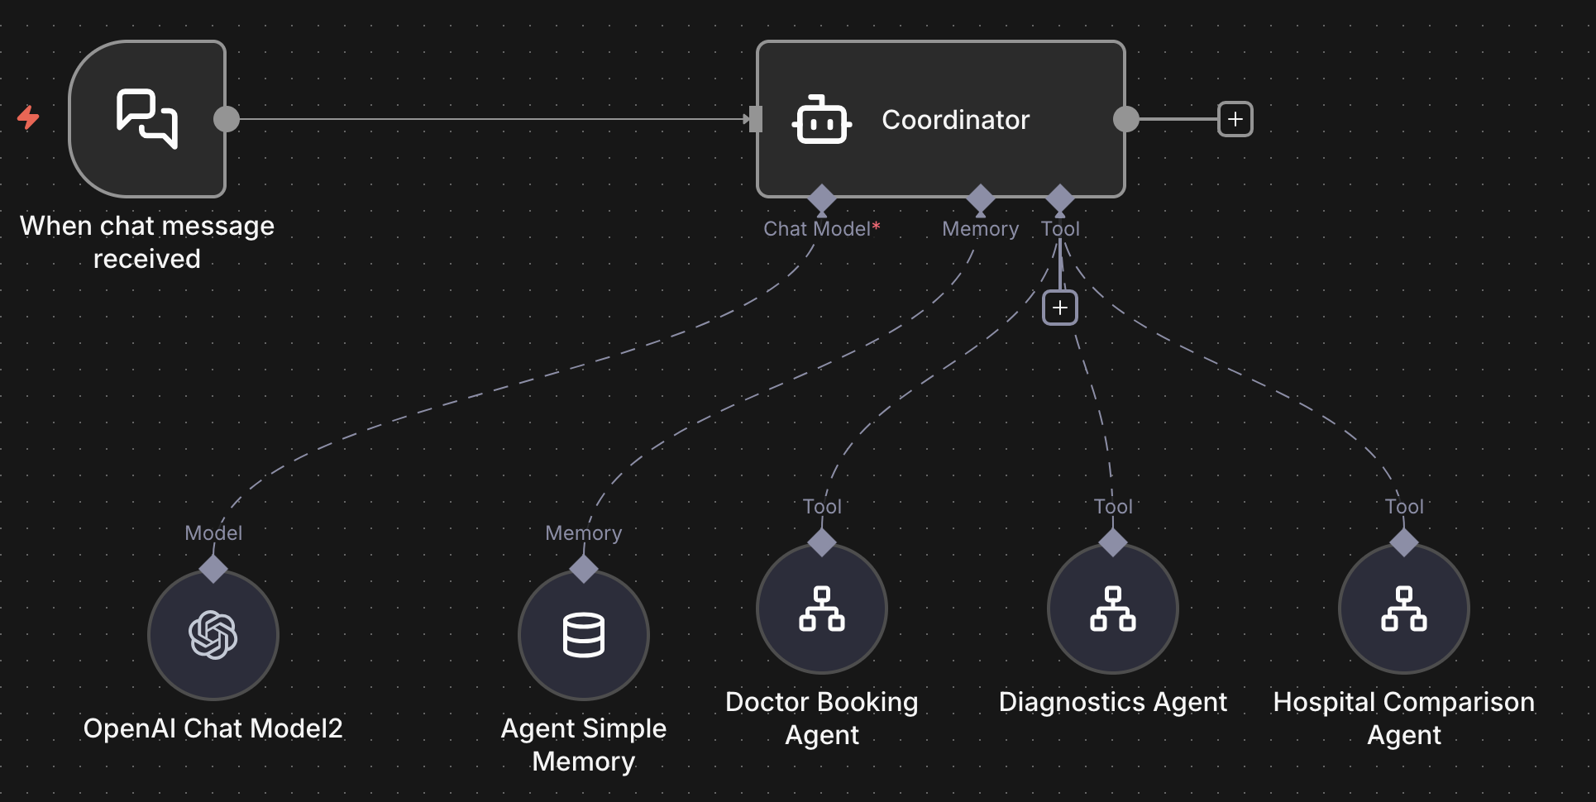

Doctor Booking Agent

Doctor Booking Agent
- Finds slots from Google Sheets
- Suggests booking & confirms via email
- n8n Json files - Click here to Download
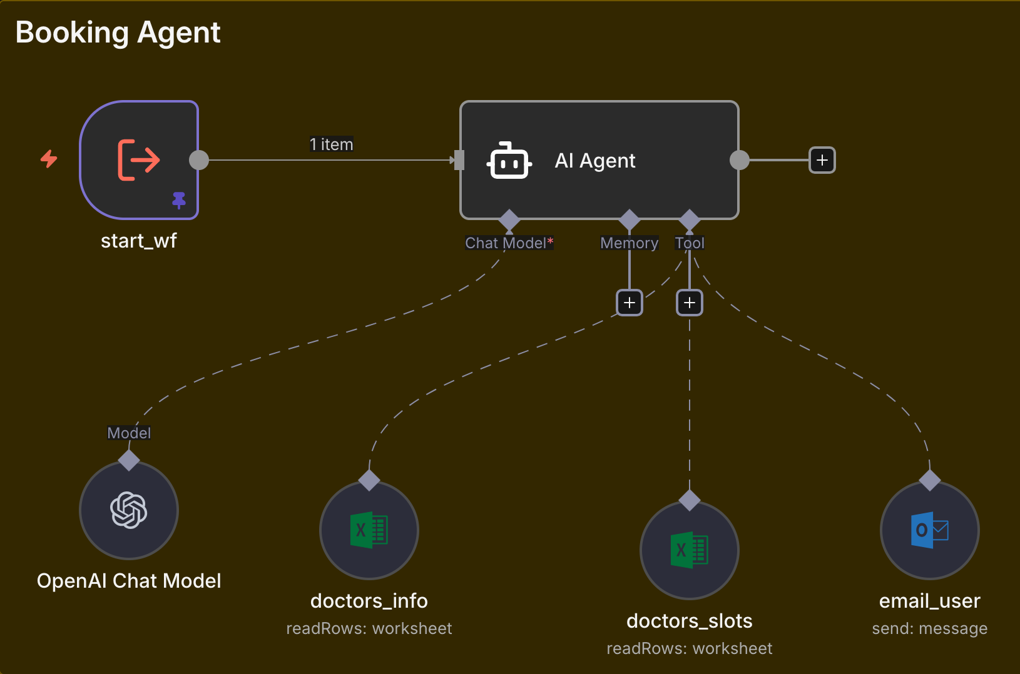

Hospital Comparison Agent

Hospital Comparison Agent
- Filters hospitals by city/specialisation/emergency availability
- Returns ranked list with contact info
- n8n Json files - Click here to Download
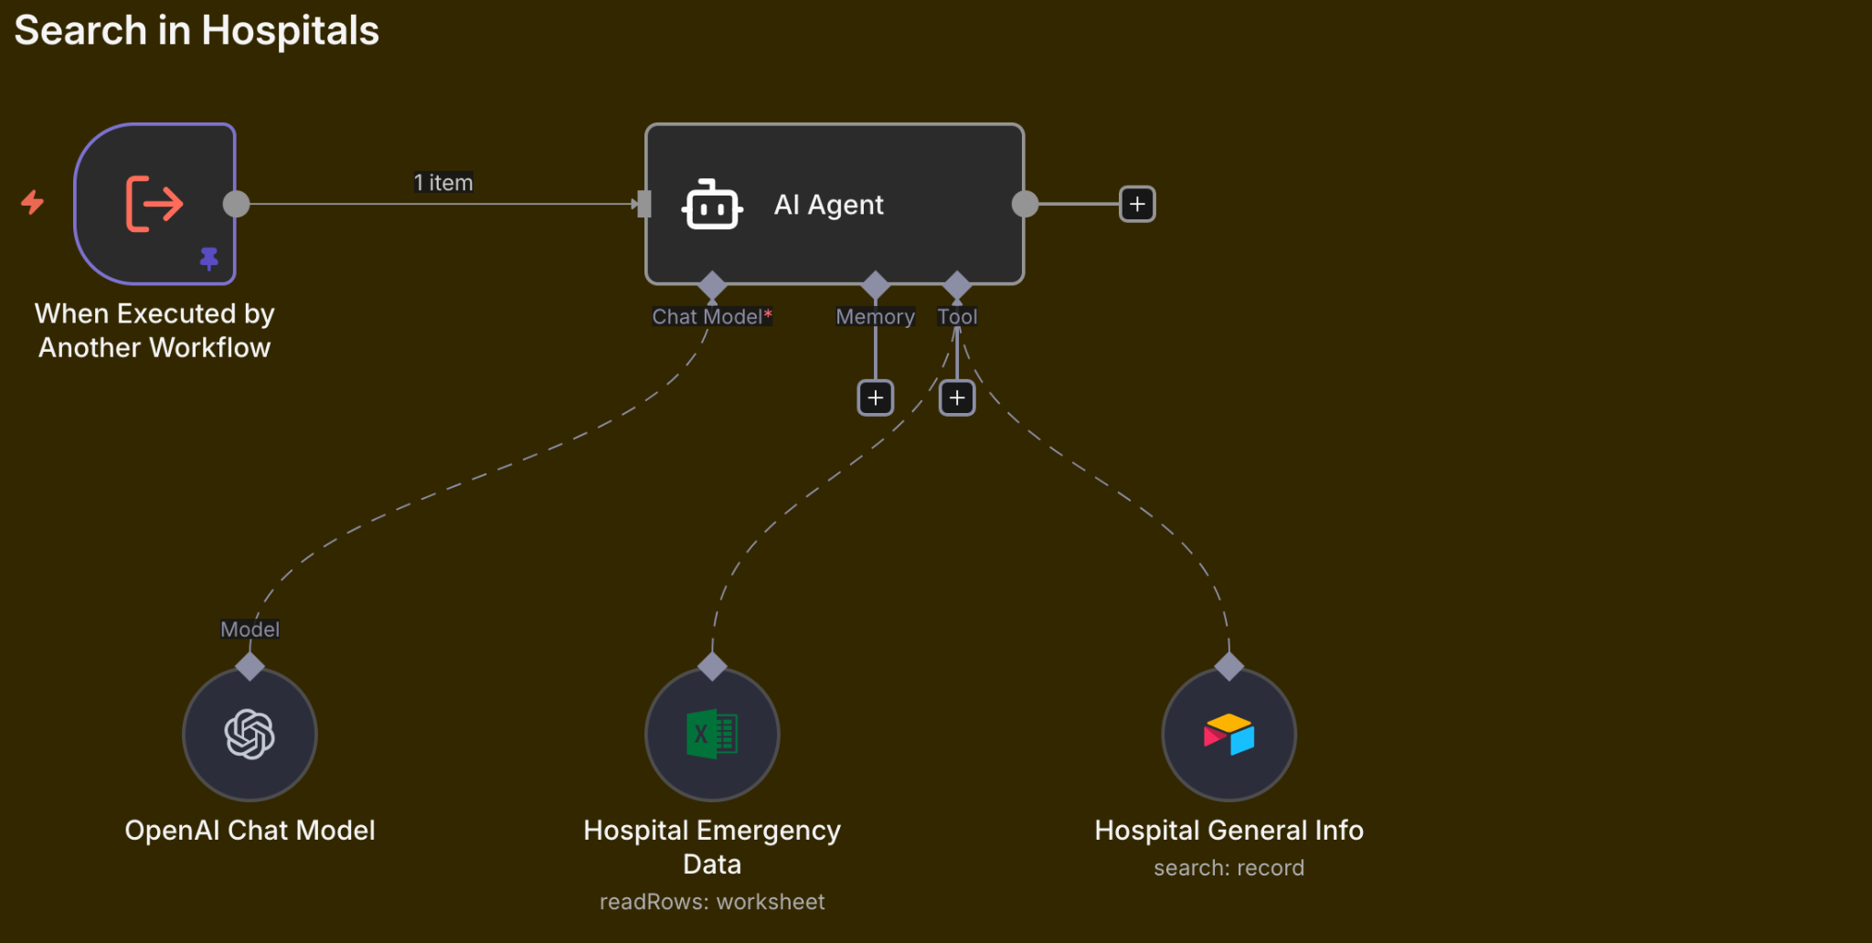

Diagnostics Agent

Diagnostics Agent
- Maps symptoms to recommended lab tests
- Fetches test descriptions & prep steps from Google Sheets
- n8n Json files - Click here to Download
